Section C ~ Vocabulary Cloze (5 x 1 mark}  
For each question from 16 to 20, choose the word(s) closest in meaning to the  
underlined word(s). Shade your answer (1, 2, 3 or 4) on the Optical Answer Sheet.

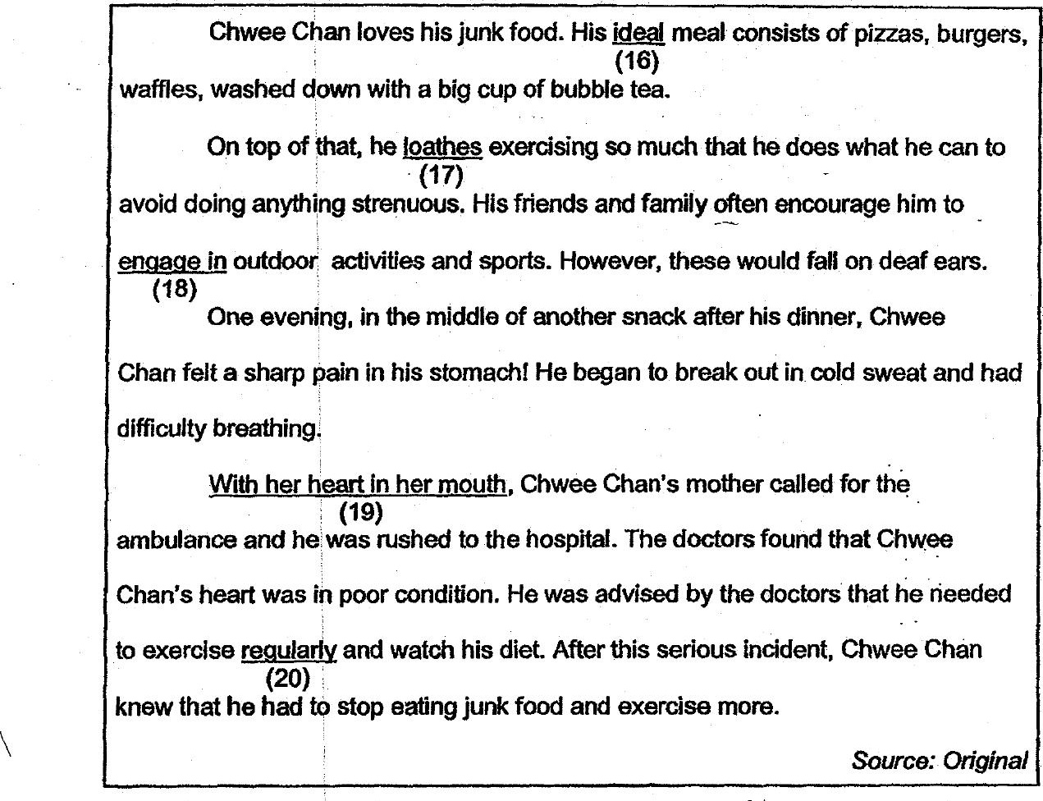

16. {1) model  
(2) perfect  
(3) supreme  
(4) complete .

17. {1) hates  
(2) ‘refuses  
(3) evades  
{4) disregard

18. (1) take up  
(2) __ take off  
(3) take over  
(4) — take down